*Florida International University*

*School of Computing and Information Sciences*

Software Engineering Focus

Feature Document

User Story ID: #725 Improve – Output of JSON file

**Name:** Filip Klepsa

**Team Member(s):** Lukas Borges, Cristian Cabrera, Hamilton Chevez, Nicolette Celli, Francico Lozada

**Project:** AR-VR-VE for Computer Science (Multimodal Interaction with ASL use case)

**Product Owner(s)**: Francisco Ortega

**Mentor(s)**: Francisco Ortega

**Instructor**: Francisco Ortega, Masoud Sadjadi

**User Story Name: Improve – Output of JSON file**

Description:

* As a developer, I want to improve the quality of the output as it is presently too raw, so that the JSON file can be used to create a database.

Acceptance Criteria:

* Limit output to a single frame or the mean of vector data collected in the set of frames.
* Format the JSON from raw data to well-formed.

**Use Case**: **Auto Capture exportJSON**

**Participating Actor:**

* User

**Entry Condition:**

* Actor must have application running and Leap Motion controller plugged in.
* Actor must have specified or verified the following Auto Capture settings: Gesture, Time out, File Count, and Start Index.
* Actor must have initiated an Auto Capture and hit Start button.

**Exit Condition:**

* The capture is completed, the file is stored in the Build/Capture directory.
* The actor is notified that the capture has completed. Gesture List is now up to date.

|  |  |
| --- | --- |
| **Actor Steps** | **System Steps** |
| 1. The actor hit start button and performs physical gestures. |  |
|  | 2. The system captures the physical gestures and saves them in the Build/Capture directory under its corresponding gesture label. |
| 3. The actor continues to perform gestures until File Count is reached. |  |
|  | 4. The system notifies the actor that the process is complete after File Count is reached. |

**Use Case Diagram**

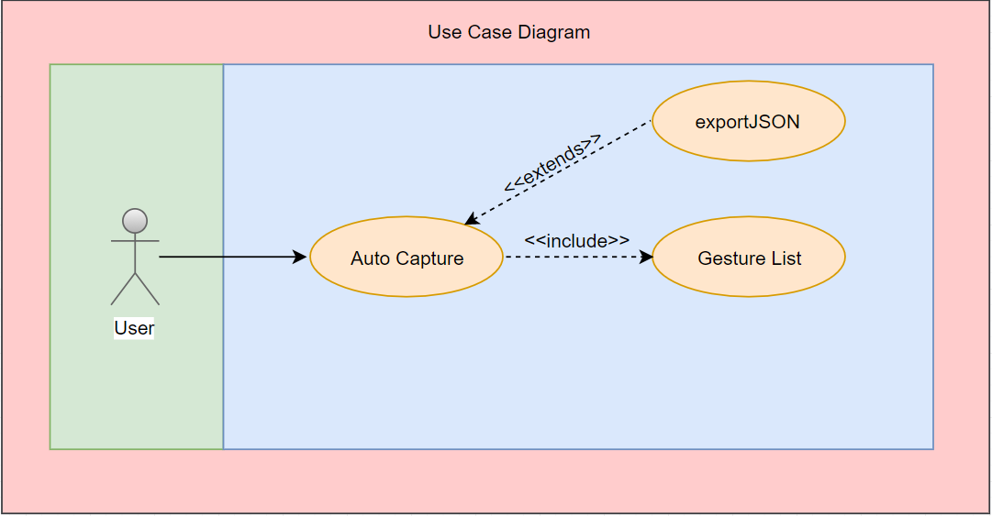

**Sequence Diagram**

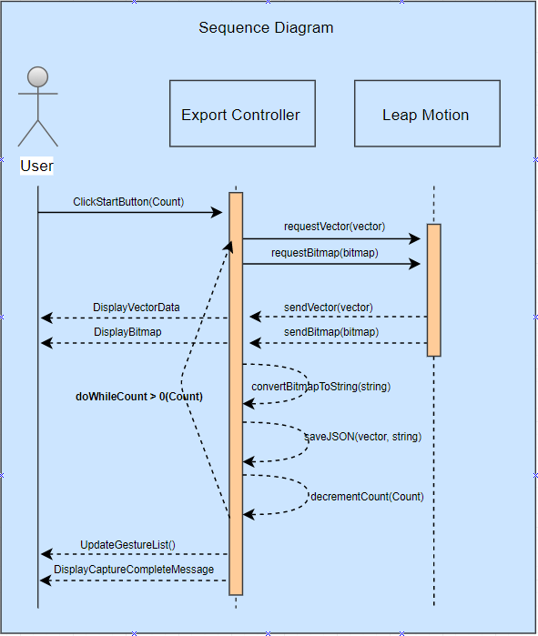

**Class Diagram**

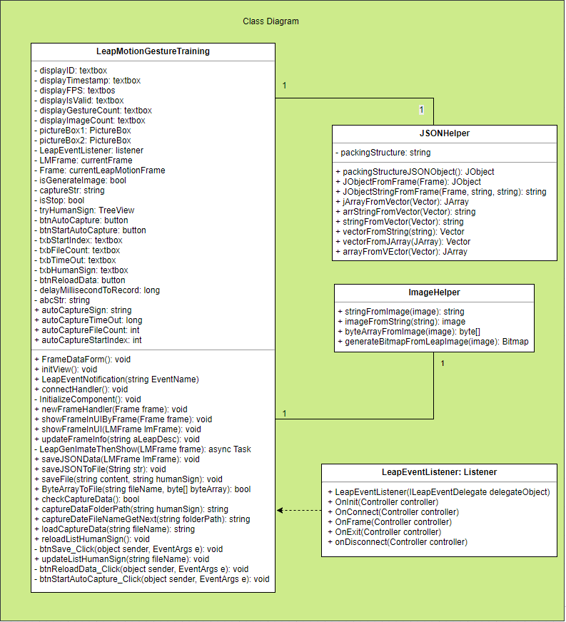

**Unit Test** -Coming Soon

* Test case ID:
* Description/Summary of Test:
* Pre-condition:
* Expected Results:
* Actual Result:
* Status (Fail/Pass):

**Integration Test**

**Visual User Guide**

